Student worksheet answers

5.1 The Earth’s spheres are balanced

Pages 112–115

Layers of Earth

1 On the diagram below, label the following:

atmosphere, biosphere, crust, hydrosphere, inner core, lithosphere, mantle, outer core

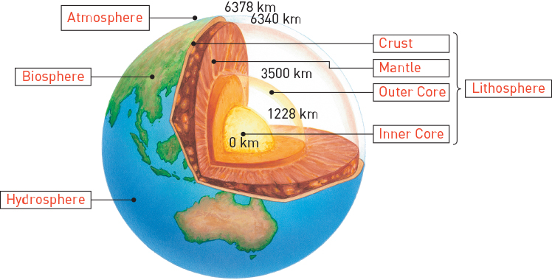

2 Fill in the following table based on your knowledge of the atmosphere, lithosphere, hydrosphere and biosphere.

|  |  |  |
| --- | --- | --- |
|  | What is it? | What is it made of? |
| Lithosphere | The layers of the Earth | Rock, magma, iron, etc. |
| Atmosphere | The layers of gases that form the air | Nitrogen, oxygen, carbon dioxide, water vapour, ozone, etc. |
| Hydrosphere | The Earth’s water, which resides in the oceans, lakes, glaciers, soil and air | Water – H2O |
| Biosphere | All the living things on the Earth, including plants, animals and bacteria | Carbon-based organisms |

3 How does the atmosphere change as you travel further away from the Earth?

Temperature decreases then increases; pressure decreases

4 In which layers of the atmosphere is the ozone layer located?

Top of the troposphere, the stratosphere, and the bottom of the mesosphere

5 In which layer of the atmosphere can an aurora be found?

Ionosphere

6 What is the cause of an aurora?

An aurora (shimmering ‘lights’ seen near the North and South poles) is caused by particles from the Sun interacting with gas particles in the magnetosphere. which is a layer of the ionosphere.

Extend your understanding

Research two planets in our solar system and determine whether they have an atmosphere, lithosphere, hydrosphere and biosphere, and what each is made up of.

7 Planet 1:

a Atmosphere

b Lithosphere

c Hydrosphere

d Biosphere

Answers will vary based on planet chosen, but should be well researched and include the composition.

8 Planet 2:

a Atmosphere

b Lithosphere

c Hydrosphere

d Biosphere

Answers will vary based on planet chosen, but should be well researched and include the composition.

Student worksheet answers

5.2 Matter cycles through the Earth’s spheres

Pages 116–119

The nutrient cycles

1 Why are the Earth’s cycles essential to sustaining life?

We need these resources to keep us alive. For example, oxygen is required for respiration – if it were lost to the atmosphere for good after every inhalation, plants would die out, animals would starve and the biosphere would collapse.

2 What is ‘useful’ oxygen in comparison to ‘non-useful’ oxygen?

‘Useful’ oxygen is oxygen that is readily accessible and able to be used easily. ‘Non-useful’ oxygen is oxygen that is stored in some way (minerals) and cannot be extracted easily.

3 Explain how each of the following spheres influence the oxygen cycle.

a Biosphere

Photosynthesis releases oxygen from the biosphere into the atmosphere, and cellular respiration absorbs oxygen from the atmosphere into the biosphere.

b Atmosphere

UV light converts water to oxygen and hydrogen, and oxygen is removed by cellular respiration, the decay of organisms and the weathering of exposed rocks.

4 What important biomolecules does nitrogen form in both plants and animals?

Proteins, nucleic acids, amino acids and DNA.

5 What are the ‘usable’ and ‘non-usable’ forms of nitrogen?

Usable forms of nitrogen are nitrate (NO3−) ions, nitrite (NO2−) ions and ammonium (NH4+) ions. The non-usable form is nitrogen (N2).

6 What do nitrogen-fixing bacteria do? What would happen if they were unable to do this?

Nitrogen-fixing bacteria ‘fix’ or convert non-usable nitrogen into the usable forms. They do this at the roots of plants so they can be easily absorbed. If they did not do this, the plant could not produce essential biomolecules and would die.

7 How is lightning able to turn atmospheric nitrogen into nitrates within the soil?

It acts as a catalyst

8 What important biomolecules does phosphorus form in both plants and animals?

ATP (adenosine triphosphate), as well DNA and RNA (sugar–phosphate backbones)

9 How does phosphorus cycle through the Earth’s spheres?

Sedimentary rocks erode and release phosphate ions into the soil. Plants absorb phosphate ions from the soil, and phosphorus continues through the food chain as the plants are eaten by animals, and so on. When organisms die, the phosphorous returns to the soil and can be locked in sediments and rocks.

10 Why is the phosphorus cycle considered to be the slowest nutrient cycle?

It takes a long time for rocks to weather/erode and release phosphate ions.

11 What is a key difference between the phosphorus cycle and the other main cycles?

There is no gas phase in the phosphorus cycle

Extend your understanding

12 In the space provided, draw a mind map that outlines how all the oxygen, nitrogen and phosphorus cycles transfer nutrients through an ecosystem. You must link all three cycles and highlight the key aspects that each cycle has in common (i.e. draw all three cycles on the same diagram).

Answers will vary, but should contains plants, animals, waterways, the atmosphere, land, soil, rocks, bacteria and dead matter. Students could highlight the three different cycles on the same mind map by drawing the arrows in different colours.

Student worksheet answers

5.3 The water cycle is a global cycle

Pages 120–123

The water cycle

1 Draw a simplified diagram of the water cycle in the space below. You must include the following:

precipitation, evaporation, condensation, transpiration, oceans, on-shore winds, surface run-off

Diagram should be based on the water cycle (student book Figure 5.11). Diagram must include transpiration, which should show water evaporating from plant leaves into the atmosphere.

2 a Label the following diagram of air movement.

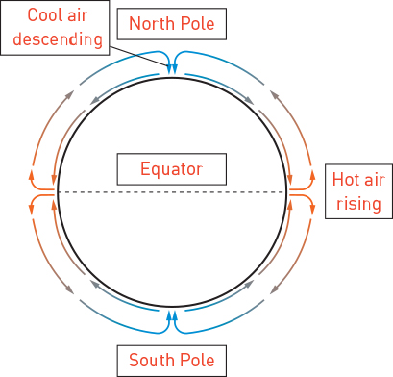

b Use the particle model of matter to explain how this diagram relates to the cycling of air through the atmosphere to create weather patterns.

Hot air rises at the equator as it has the most access to the Sun. When air particles heat up, they gain kinetic energy and increase their movement, forcing them further apart, making them less dense and therefore rise. When air particles reach the poles, they cool, lose kinetic energy, get closer together, become more dense and fall.

3 Label the following weather map.

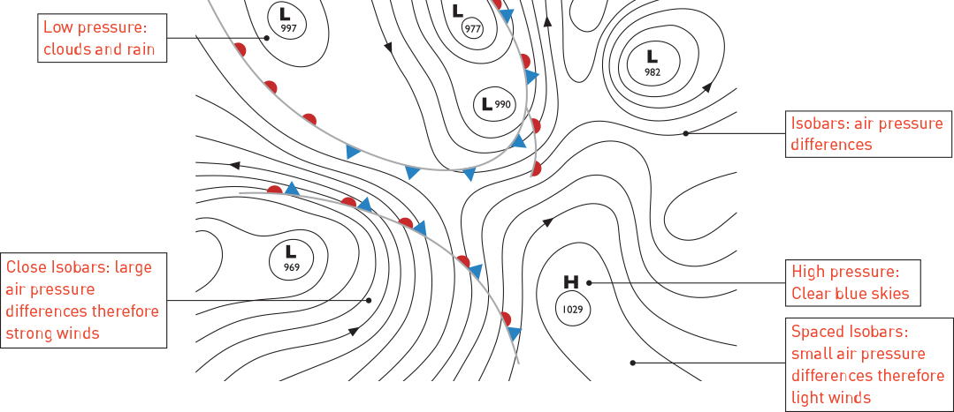

Extend your understanding

4 You are going on a holiday to your dream location, but it is important that you pack appropriately. Access a current weather map of your chosen location and determine the weather conditions that are currently occurring. Write a brief report describing these conditions and what you would pack for your holiday. You must draw or attach the weather map and label it as you did in question 3 above.

Answers will vary based on the chosen location, but MUST include a weather map that is fully labelled. Students must then use the weather map to determine the weather conditions and what they would pack.

Student worksheet answers

5.4 Human activity affects the carbon cycle

Pages 124–125

Human impacts on the carbon cycle

1 How do humans use the geological carbon cycle to their advantage?

By extracting oil, natural gas and coal, all of which are hydrocarbons, for use in cars and energy production

2 What is the impact of this on the environment?

Large-scale extraction and use of fossil fuels has resulted in increased levels of carbon dioxide in the atmosphere

3 List two major carbon sinks that have the greatest impact on the level of atmospheric carbon dioxide.

Oceans and forests

4 Other than carbon sinks, where else can carbon be stored?

• Decomposed organic matter, such as coal, natural gas, petroleum and shale oil

• Rocks, such as limestone, marble, dolomite, chalk and other carbonates

• Organic matter in the soil

• Dissolved carbon dioxide in the oceans and other waters

• The shells of marine organisms and some terrestrial organisms

5 What is the pedosphere?

The outermost layer of the lithosphere – the soil/earth

6 How does the pedosphere contribute to the level of carbon dioxide in the atmosphere?

Carbon from microbes in the soil is released into the atmosphere

7 Draw a simplified version of the carbon cycle below. You must include the ocean, atmosphere, carbon dioxide, plant material, crude oil, burning of plant material, burning of fossil fuels and aquatic organisms. You must also include labels of the features involved with the geological carbon cycle and the biological/physical carbon cycle.

Answers will vary, but should follow the format of student book Figure 5.17 and identify:

• geological carbon cycle: rocks, crude oil, coal, etc.

• biological/physical carbon cycle: trees, animals, photosynthesis, respiration, water, carbon dioxide, etc.

Extend your understanding

Nuclear power plants were developed as a solution to climate change.

8 Does a nuclear power plant release carbon as waste, and therefore impact the carbon cycle?

No – it is considered to be a ‘green’ chemical process as no carbon dioxide is emitted

9 How is energy generated in a nuclear power plant? Use a chemical equation to support your answer.

Nuclear fission– this involves splitting the nucleus of a uranium atom into two smaller parts, which releases energy.

235U + 1n (a neutron) → 142Ba + 91Kr + 3 1n

There are three neutrons formed in this reaction, which are then used in more reactions.

Answers will vary as these are not the only products formed in nuclear fission from uranium.

10 What waste is produced from this process?

Atomic fragments, which are produced as products of the reaction as only neutrons are used again.

11 What are the disadvantages of nuclear power plants?

Nuclear power is a non-renewable energy source as uranium is mined from the ground. It also produces radioactive waste that is harmful to plants, animals and the environment. The waste remains radioactive for hundreds, thousands, and sometimes millions of years.

Student worksheet answers

5.5 Evidence supports enhanced global warming

Pages 126–129

Evidence for global warming

1 What are the main greenhouse gases?

Carbon dioxide, methane, water vapour

2 How do greenhouse gases regulate the Earth’s temperature?

They reflect radiation from the Sun and retain the warmth from the Earth.

3 Where can evidence for global warming be found?

In the melting of sea ice and permafrost, and increasing sea levels

4 What would happen to the Earth if there were no ozone layer?

The temperature would drop to –100°C each night and rise to 80°C in the day, as there would be no ozone to keep heat in or stop heat from entering into the atmosphere

5 What is the difference between the greenhouse effect and enhanced greenhouse effect?

The greenhouse effect refers to the natural fluctuations of the Earth’s carbon dioxide levels, whereas the enhanced greenhouse effect refers to the increases in these levels that humans cause

6 What is the difference between natural greenhouse gases and fossil fuel greenhouse gases? Which is more harmful? Explain why.

Natural greenhouse gases are produced by plants and animals as a part of natural processes, such as photosynthesis. Fossil fuel greenhouse gases are released through the burning of fossil fuels. Fossil fuel greenhouse gases are more harmful as they increase the level of gases whereas natural greenhouse gases recycle the gases.

7 Using the data in student book Figure 5.20, explain why the concentration of carbon dioxide in our atmosphere is concerning.

The level of carbon dioxide (CO2) in our atmosphere is at a concentration it has never reached before. Any events that occur as a consequence may be unpredictable and never seen before.

8 Which countries are the biggest contributors to carbon dioxide emissions?

North America and China

9 What is the trend in global temperatures since 1900? Explain why this has occurred.

In all continents of the world, the temperature anomaly has increased by approximately 1°C since 1900. This has occurred because more CO2 in the atmosphere is trapping heat and not letting it back out into space.

10 What is the trend in sea levels over the past 100 years? Explain why this has occurred.

There has been a dramatic rise in sea levels over the past 100 years. This has occurred as a result of enhanced global warming melting ice at the polar ice caps.

11 Using student book Figure 5.22, list at least four factors that contribute to human-induced climate change.

Answers may vary. Factors include:

• Burning of fossil fuels in power plants

• Carbon monoxide from car engines

• CO2 from aeroplane travel

• CO2 from burning from forest clearing releases greenhouse gases

• Fluorinated gases from propellants and coolants

• Methane from animals and nitrous oxide from fertilisers

Extend your understanding

Ice cores provide essential data, which has aided in the development of the graph in student book Figure 5.20.

12 Explain why ice cores are used to gather this data.

Ice cores contain data based on thousands of years of heating and cooling in summer and winter. Snow falls each winter, which melts and compacts every summer. This means that ice forms in layers, which can be seen in ice cores. The layers can be analysed and reveal any changes over time.

13 Explain what scientists look for in ice cores to collect data.

Ice cores can aid scientists in determining the severity of a winter (in terms of the snow fall), the temperature of the Earth at the time, and the concentration of carbon dioxide in the atmosphere (as small bubbles of air contain a sample of the atmosphere of that time).

Student worksheet answers

5.6 Enhanced global warming has widespread effects

Pages 130–133

Effects of global warming

1 What effects are expected to be seen when global temperatures rise?

An increase in the number of extreme weather events, an increase in mosquito-borne diseases, and a decrease in biodiversity.

2 What is the difference between a regular storm and one that is influenced by climate change?

Scientists predict that storms influenced by climate change will have greater maximum wind speeds and more sudden and extreme rainfall

3 What are the possible consequences of storms influenced by climate change?

More intense tropical cyclones will cause flooding, landslides, damage to buildings and the number of cyclones reaching category 4 or 5 will rise as cyclones intensify over warm ocean waters. We can also expect to see an increase in the loss of human lives as a result.

4 How can climate change cause weather patterns that result in negative health effects? Outline three examples.

• A heat wave in Europe in 2003 was estimated to have killed between 22 000 and 35 000 people.

• Dengue fever and malaria, which thrive in warm and moist conditions, have increased incidence zones.

• Stagnant weather conditions trap warm air and pollutants, leading to smog, which results in serious respiratory problems.

5 Which animals are most at risk due to global warming? Explain why.

Arctic and Antarctic animals, such as polar bears and emperor penguins, are at risk. These animals live on the ice – as the ice is melting due to global warming, their habitat is being destroyed.

6 Why hasn’t the white lemuroid possum been seen in over 3 years?

They cannot survive in extended temperatures over 30°C, which occurred in 2005. It is possible they have been made extinct.

7 Why is the survival of many plants and animals at risk due to climate change?

Plants and animals can only survive within a narrow range of temperatures, making them vulnerable to changing temperatures of 1–2°C that are expected as a result of global warming.

8 Using student book Figure 5.29, explain why the ocean is referred to as a ‘conveyor belt’.

Cold, dense, salty water moves to the ocean floor. Warm, less dense, less salty water rises to the surface. Water cools at the poles (less salty as poles melt) and warms at the equator. The differences in salinity and temperature drive the movement of large currents of water.

9 What impact does a change in ocean currents have on weather patterns?

El Niño occurs when the waters of the Pacific Ocean are warmer than normal. This causes more rain to fall in the Pacific Basin instead of northern Australia. A La Niña event occurs when the Pacific Ocean is cooler than normal, causing increased rainfall and possible flooding in Australia.

Extend your understanding

Coral bleaching is occurring throughout the world, but most especially in Australia’s Great Barrier Reef. Research coral bleaching and answer the following questions.

10 Why does rising sea temperatures result in ocean acidification?

Carbon dioxide from the atmosphere dissolves in the oceans, forming carbonic acid. This decreases the pH of the world’s oceans, resulting in an acidic ocean. More carbon dioxide results in more acidic oceans.

11 What is coral bleaching and what causes it?

Coral and algae depend on each other to survive – the coral eats the algae, giving the coral nutrients and colour. When stressed in acidic water conditions, the algae leave the coral and are no longer available for the coral to eat. This results in coral bleaching.

12 What is the impact of coral bleaching on aquatic life?

Coral bleaching results in the death of the coral. This leads to less genetic and species diversity of coral, and decreasing populations may result in extinction. Coral bleaching also reduces the number fish that depend upon coral for food, resulting in species migrating elsewhere for food sources.

13 Is coral bleaching reversible? Explain your answer.

No – coral bleaching is irreversible as it results in the death of the coral.

Student worksheet answers

5.7 Humans can reduce global warming

Pages 134–135

Reducing global warming

1 What is a carbon tax and what is its purpose?

It is a fee for each tonne of carbon that a business emits. It is a government incentive to encourage industries to reduce their carbon emissions.

2 What is carbon farming?

The process of growing plants that are not harvested for firewood, building or any other purpose. Carbon is removed from the atmosphere and ‘locked away’ in the plant for hundreds of years.

3 What may be a disadvantage of carbon farming?

Answers will vary. Carbon farms take land away from food farming, which is concerning based on increasing world populations.

4 Microbiologists are modifying the bacteria present in the stomachs of cows to reduce methane production. Suggest an alternative method to reduce methane production.

Answers will vary. For example, people could adopt a more vegetable-based lifestyle or become vegetarian. This would decrease the number of cows required as a food source, and would therefore reduce methane production.

5 Outline the process of geosequestration in reducing carbon emissions.

Geosequestration involves capturing carbon dioxide from power station chimneys, separating it, and compressing it into a liquid. The liquid is then pumped into depleted oil or gas wells, and sealed with a solid plug of thick clay. This stores the carbon underground.

Extend your understanding

Throughout the 2010 election campaign where Tony Abbott was running against Julia Gillard for Australian Prime Minister, the Australian Youth Climate Coalition (AYCC) ran a campaign to get all of Australia discussing climate change. This clever campaign forced both candidates and the Australian public to focus on the issue of climate change. Research the AYCC and answer the following questions.

6 What did the AYCC do in this campaign?

They hired all the elephant costumes from around Australia, and followed politicians and media reporters around holding signs that educated about climate change.

7 Why did they do this?

As a way of communicating that climate change is the ‘elephant in the room’, that is, that climate change is there and is obvious, but no one wants to talk about it. They wanted to raise awareness in the Australian public and force politicians to discuss climate change.

8 Outline the advantages of their campaign

Answers may vary. It was clever, had a strong/clear message, was entertaining and got people talking about the issue.

9 Why does the AYCC state that climate change is both a crisis and an opportunity?

The AYCC believes that climate change is the crisis of our current lifestyle, but it also provides the current generation with an opportunity to make the world better, educate others and lead change.

10 How long does the AYCC predict it will take for Australia to become 100% powered by renewable energy sources?

10 years

11 What are the values of the AYCC?

• We are a movement, and young people will be at the forefront

• We are inclusive and diverse

• We want solutions to climate change that are just and sustainable

• We are political, but non-partisan

• We are ambitious, grounded in climate science, and solutions-focused

• We respect the leadership of Aboriginal and Torres Strait Islander people

• We are all learning